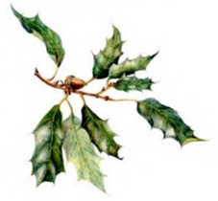
MT MACEDON & DISTRICT HORTICULTURAL SOCIETY INC
2025 AUTUMN FLOWER & PRODUCE SHOW
ENTRY FORM*

Name: |  | Office Use only (Entry Number)
Email:
Contact No:
Remember – All entries to be staged between 8:00 am and 12 noon on Saturday 15 March
Class | Number | Entry Description
Example: E | 33 | 1 container cyclamen
 |  | Put your cursor in this cell and hit tab here if you need extra rows

*Please save this form as ‘Entry your name’. For example, Entry Daisy White and email, at the latest, by 10:00 pm Thursday 13 March to:
leanne.tim@gmail.com

